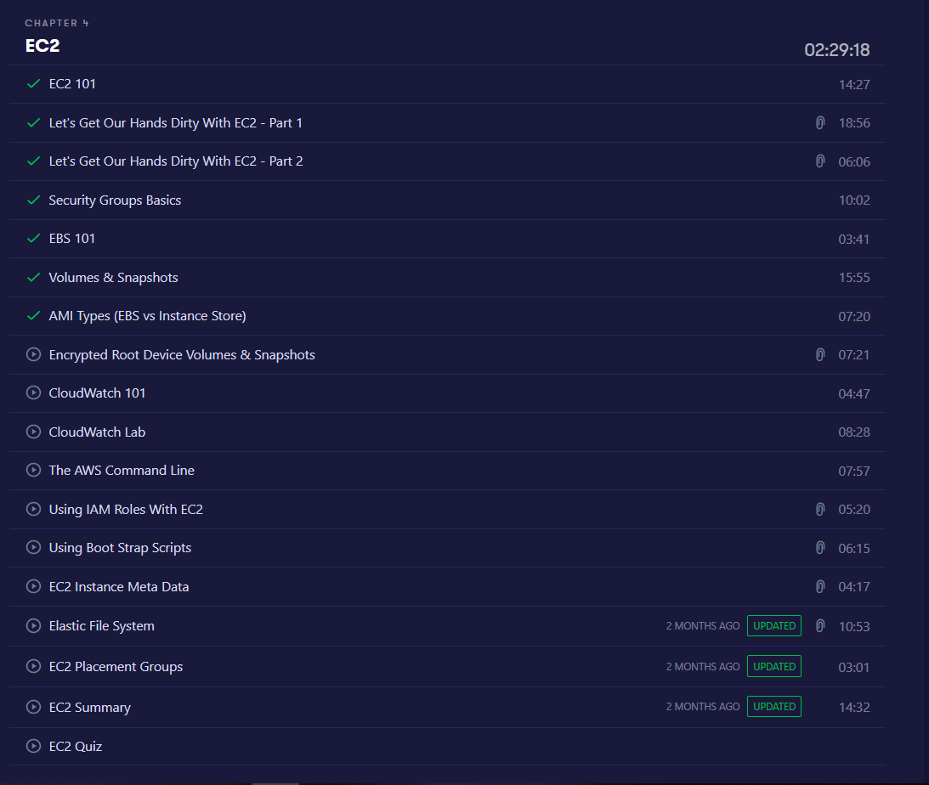

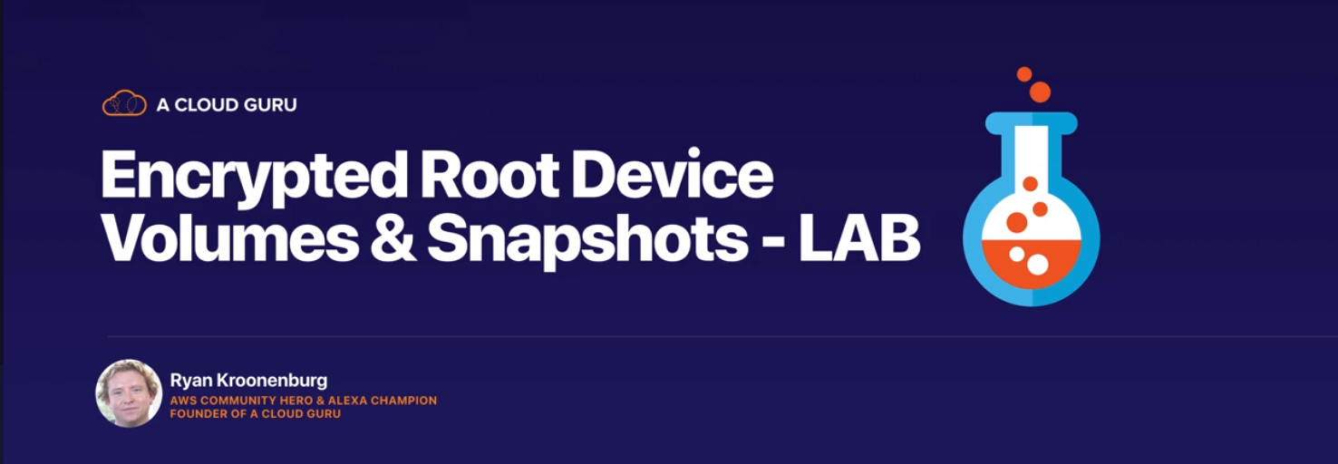

Launch EC2 instance as specified before and at step 4

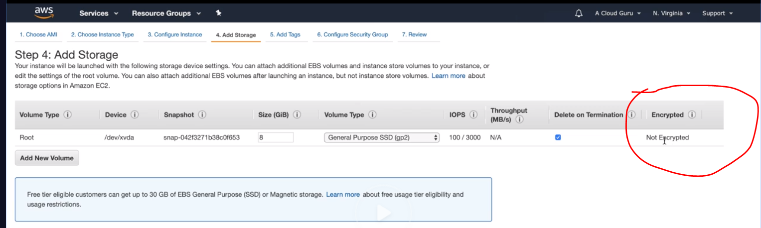

Observe root can not be encrypted but other volumes can be like EBS **Amazon Elastic Block Store** (**Amazon EBS**), also we can choose what encryption key we need

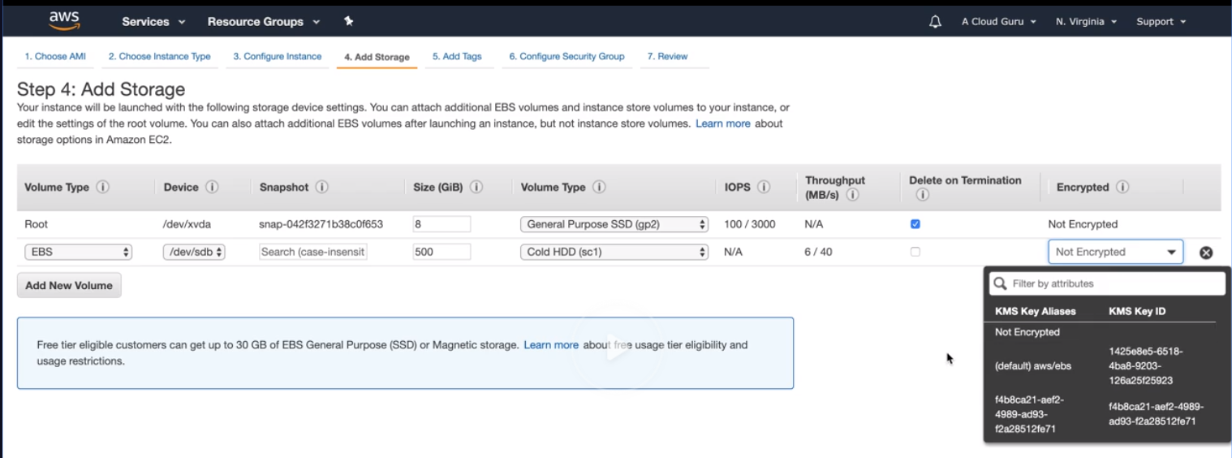

Create the EC2 instance with just root volume

After EC2 is up and running create a snapshot of the volume , here we are trying to show how we can encrypt the root volume

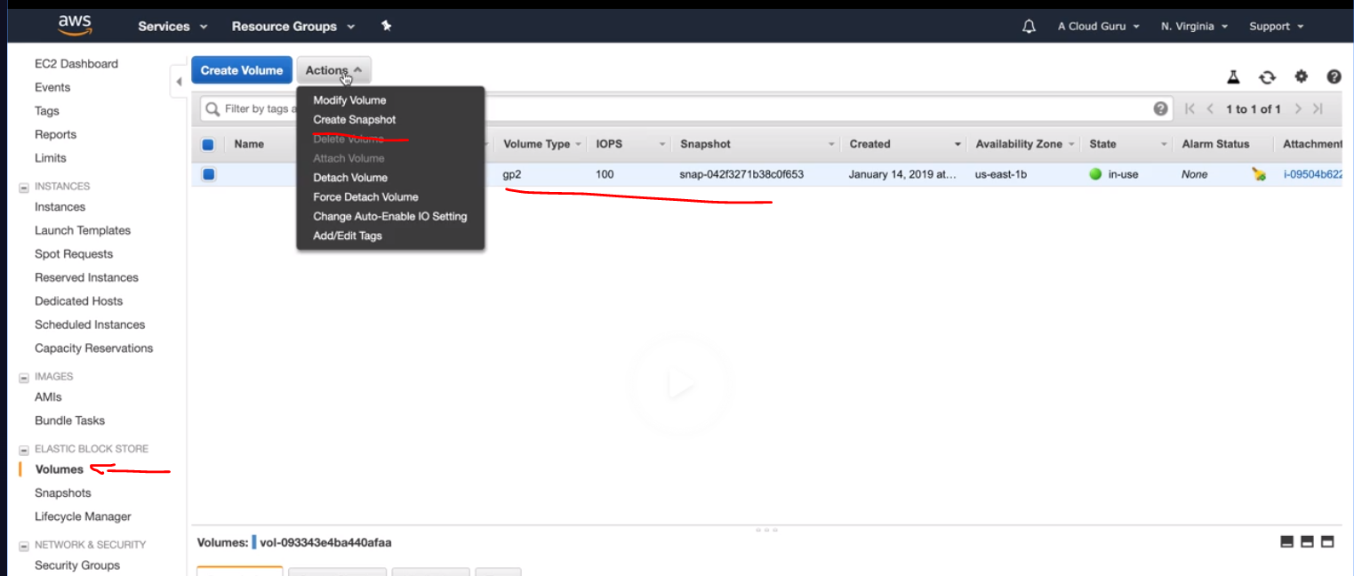

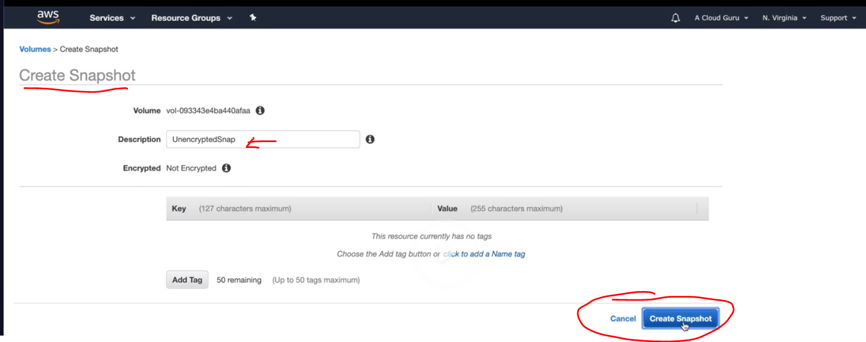

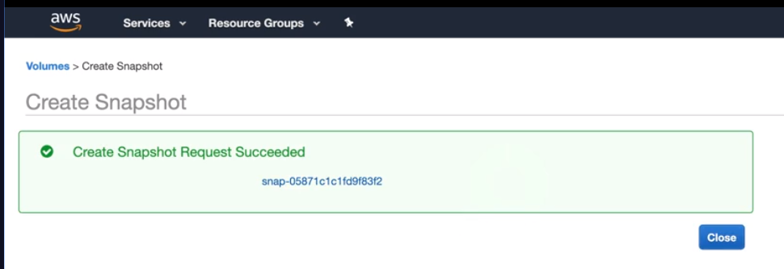

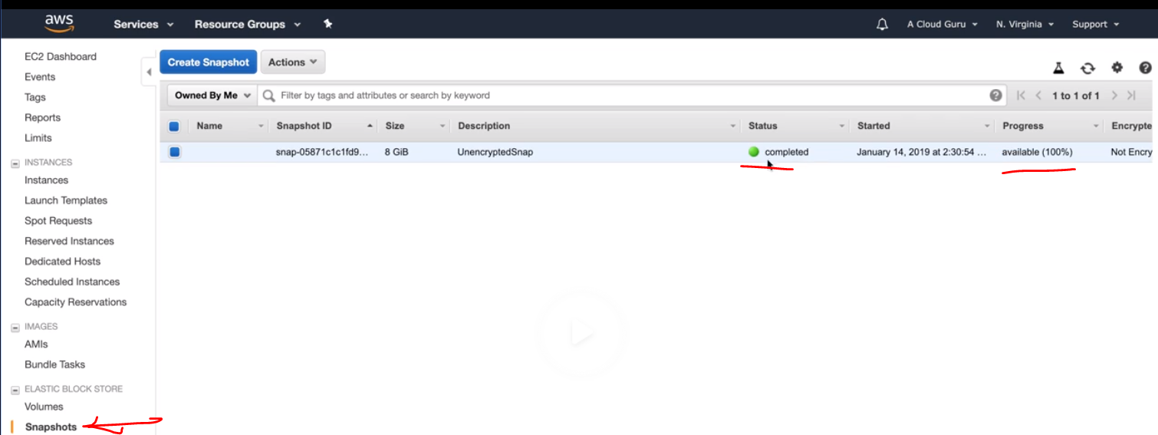

What is the difference between ec2 and AMI?

The **Difference Between** EBS Snapshots and **AMI** Images. ... An **AMI** image is a backup of an entire **EC2** instance. Associated with an **AMI** image are EBS snapshots. Those EBS snapshots are the backups of the individual EBS volumes attached to the**EC2** instance at the time the **AMI** image was created.

Copy the snapshot and choose encryption option

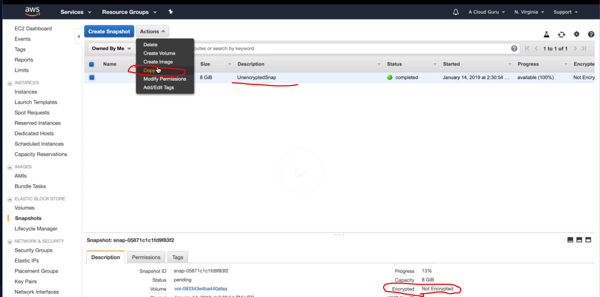

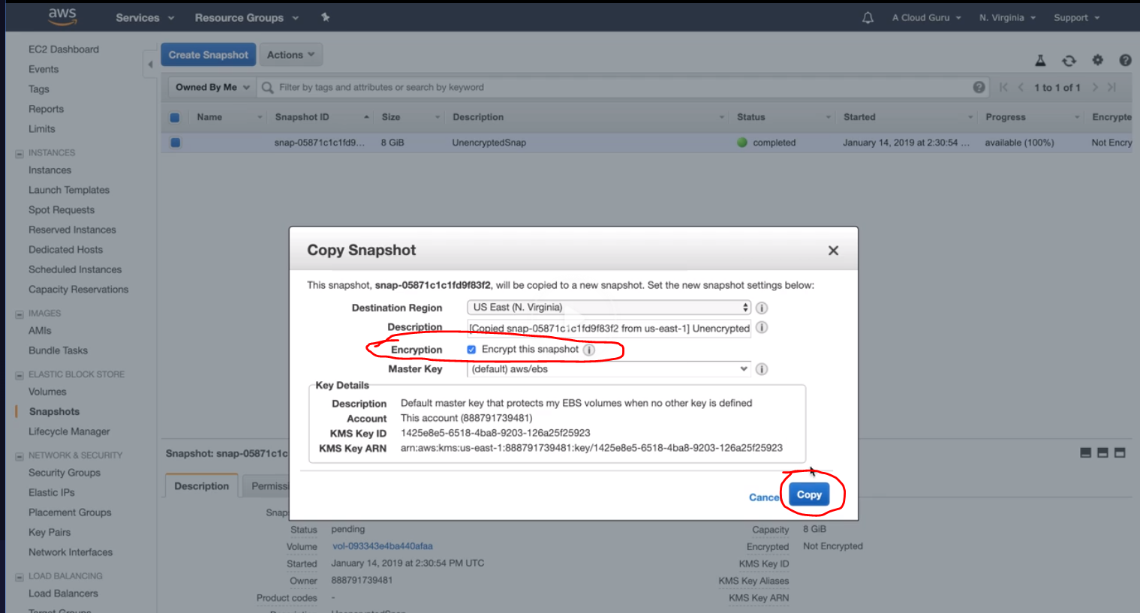

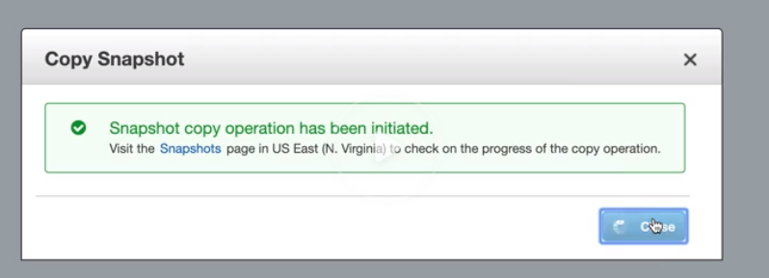

Now we have both encrypted and unencrypted snapshots

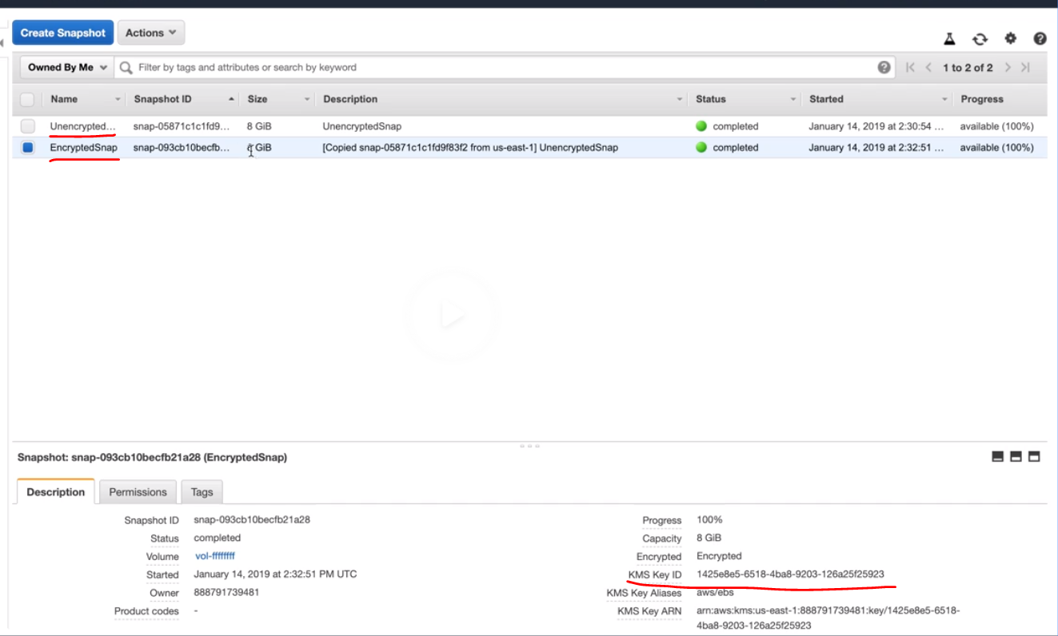

Now if you see the Encryption is disabled to show it is always encrypted.

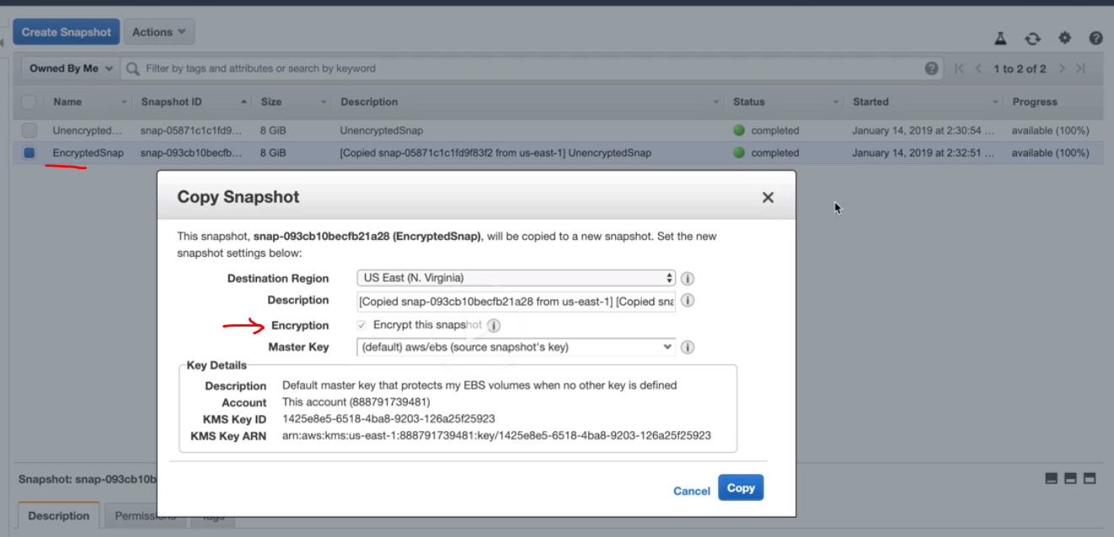

Create an image out of the encrypted snapshot

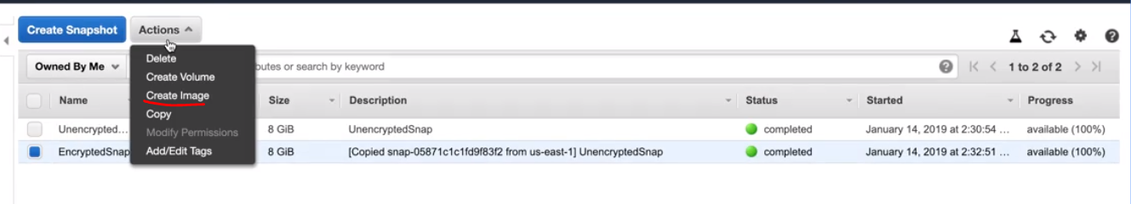

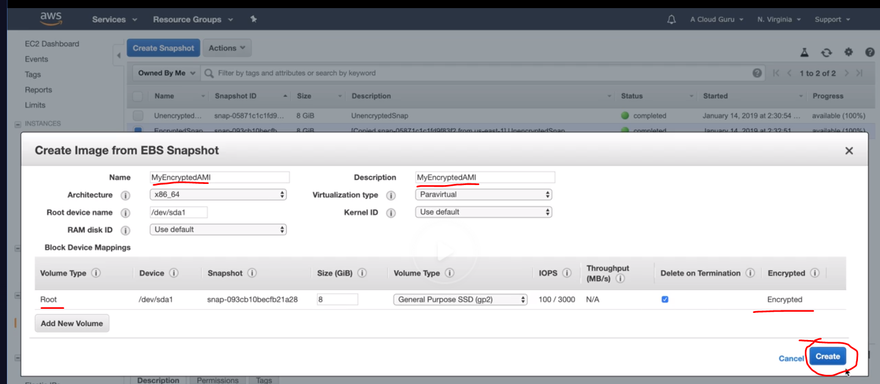

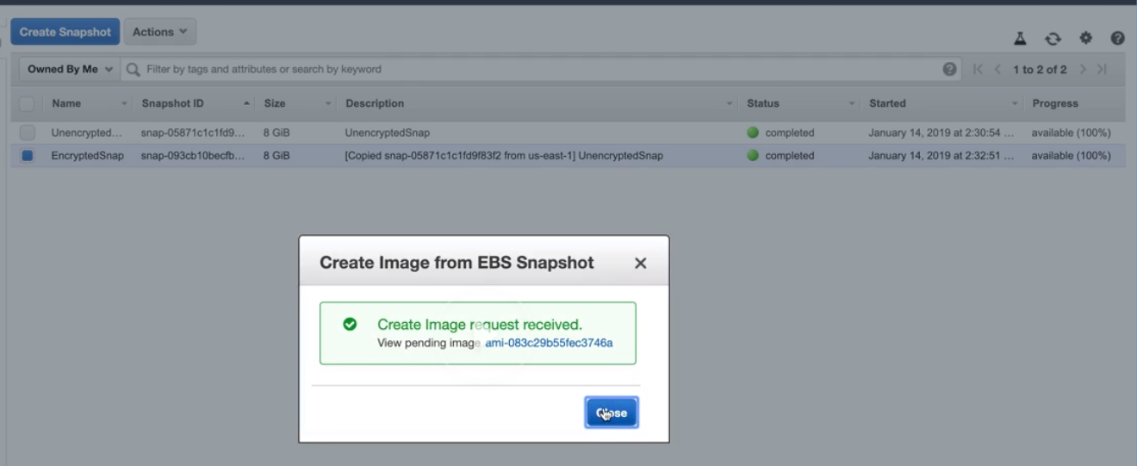

Now under AMI Menu we can see the newly created AMI which is encrypted

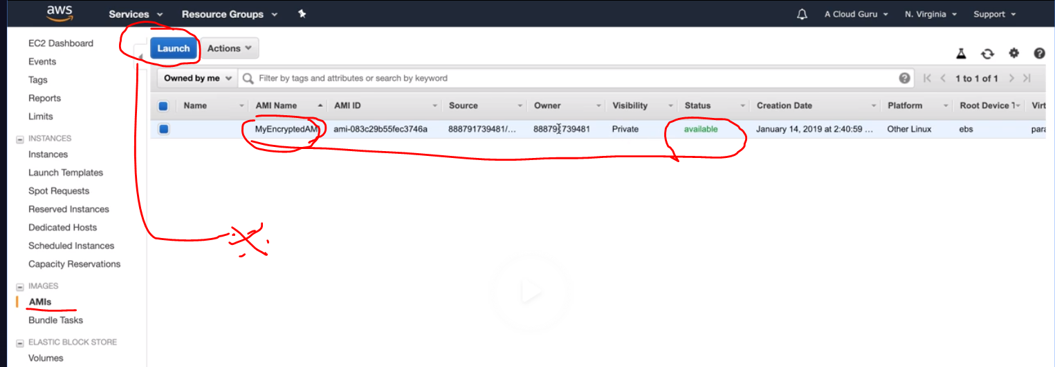

Now I can launch it and go thru the launch steps and see in step4 it is encrypted root volume.

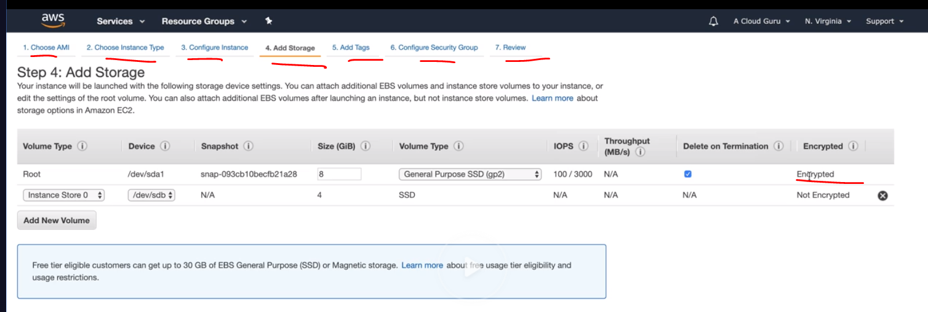

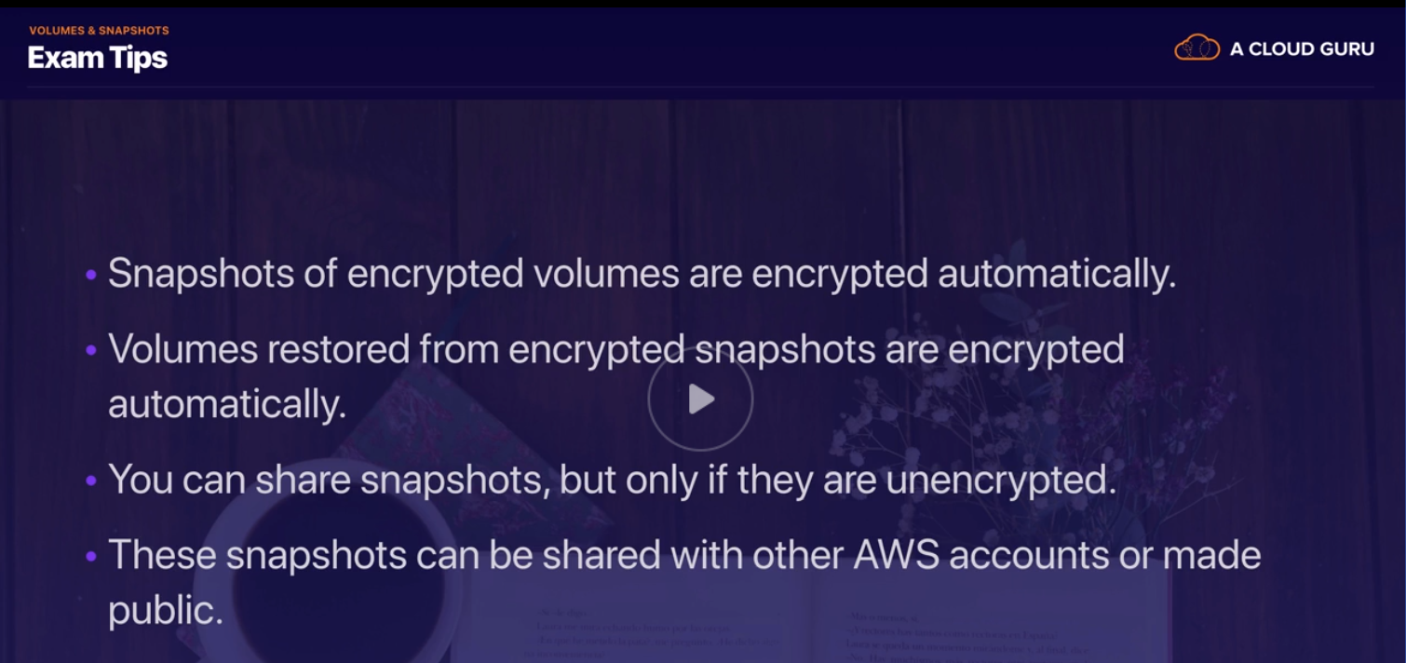

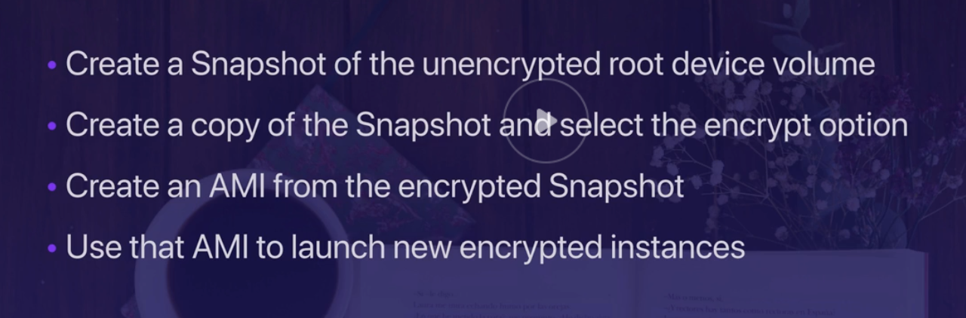

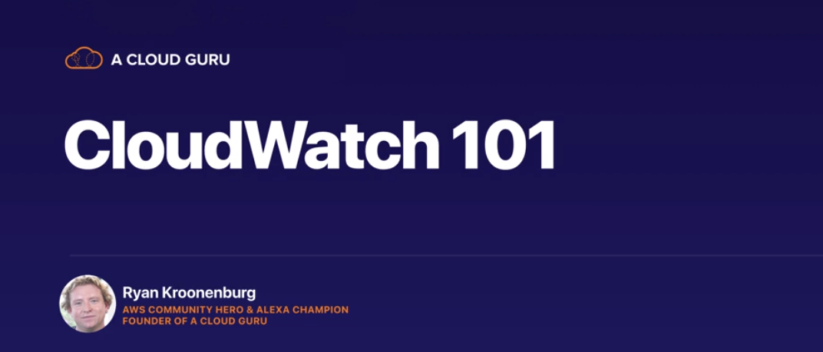

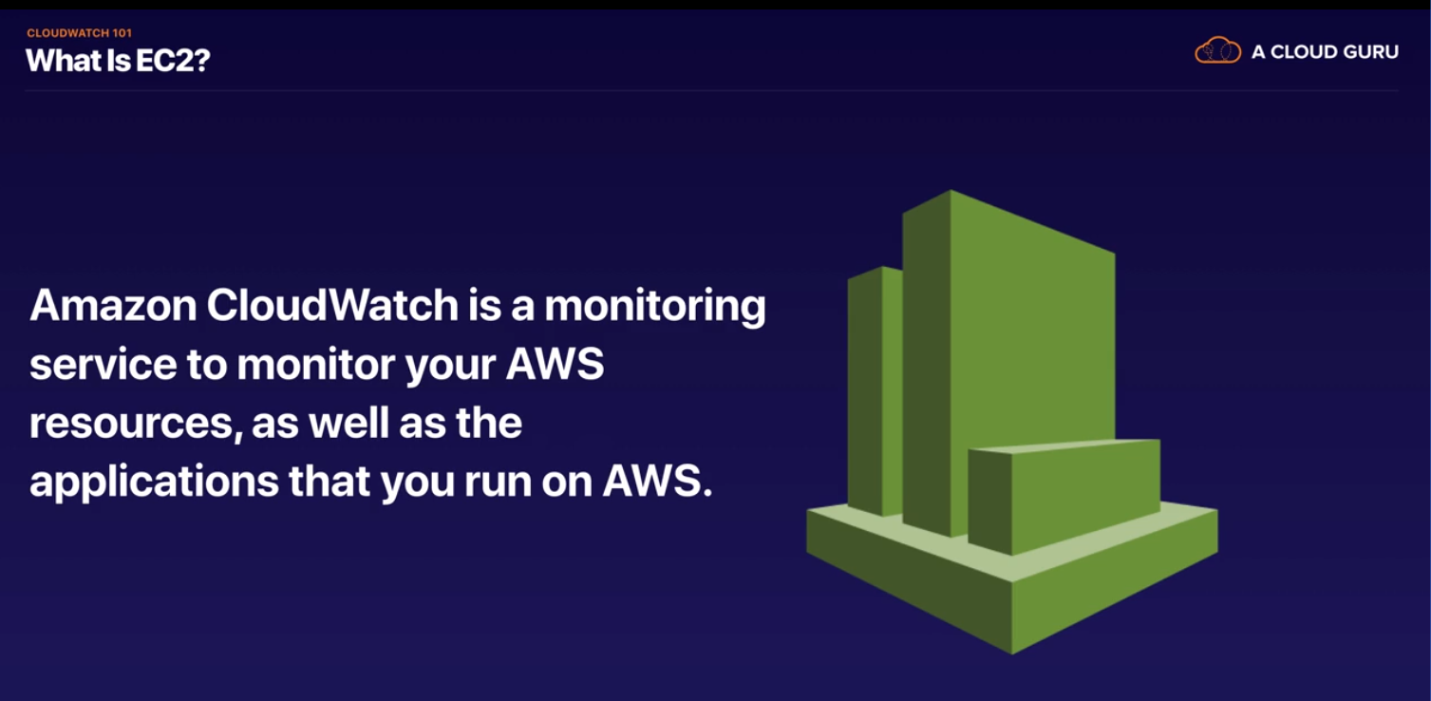

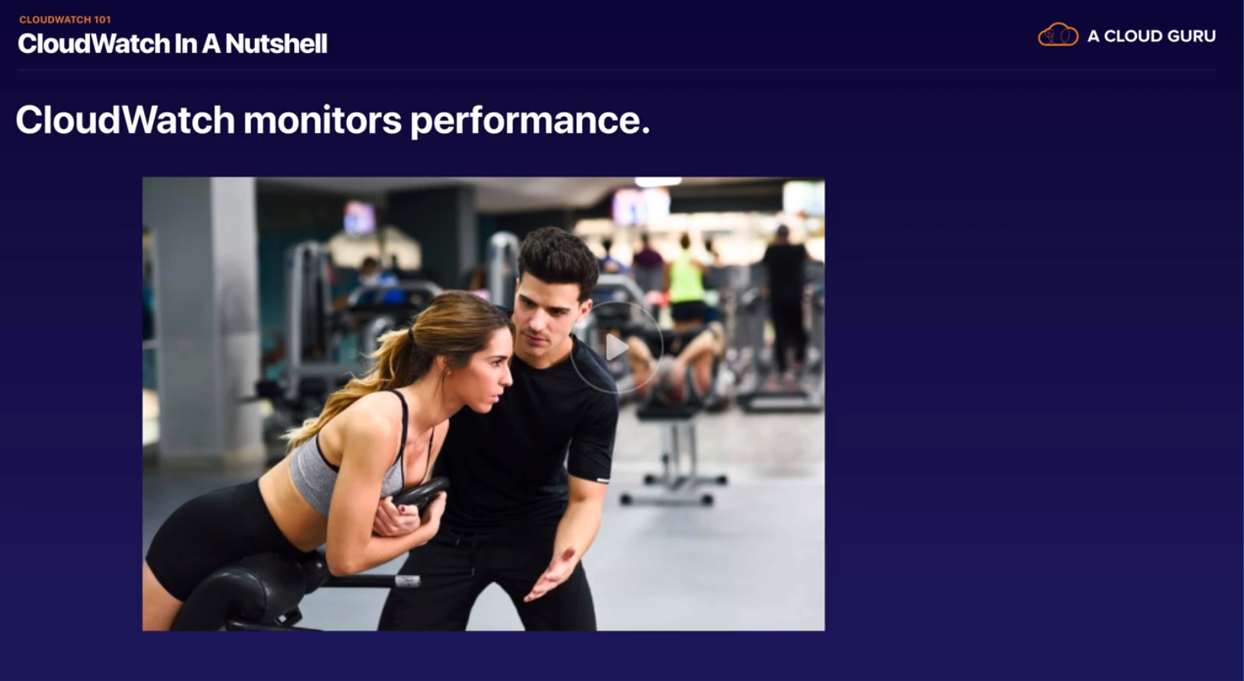

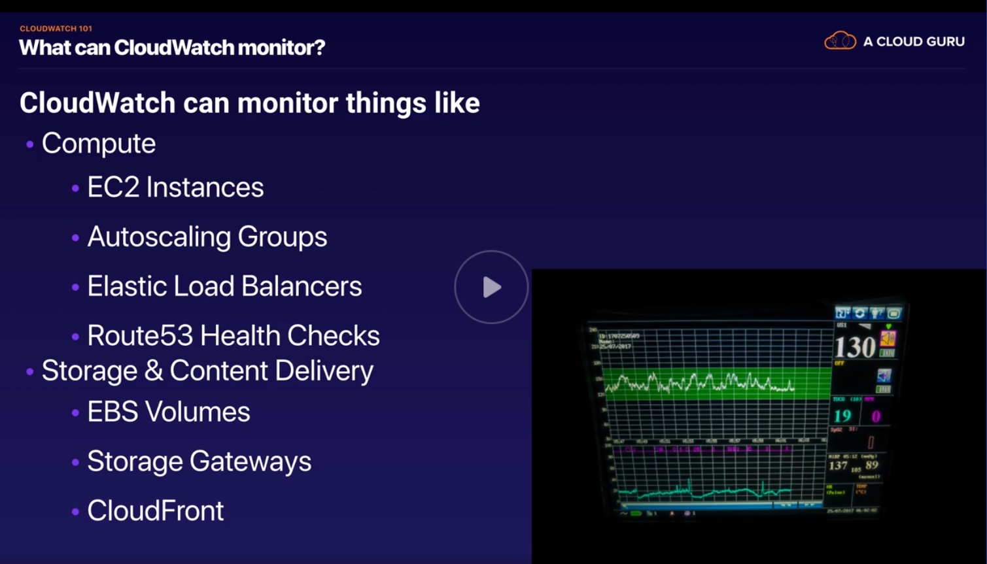

What is hypervisor in cloud?

**Hypervisors** are virtual machine monitor(VMM) that enables numerous virtual operating systems to simultaneously run on a computer system. These virtual machines are also referred as guest machines and they all share the hardware of the physical machine like memory, processor, storage and other related resources.

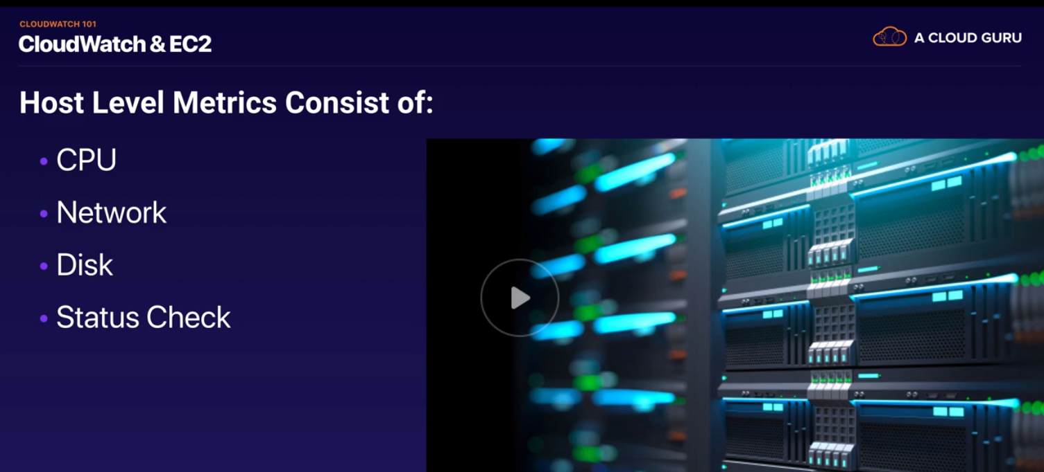

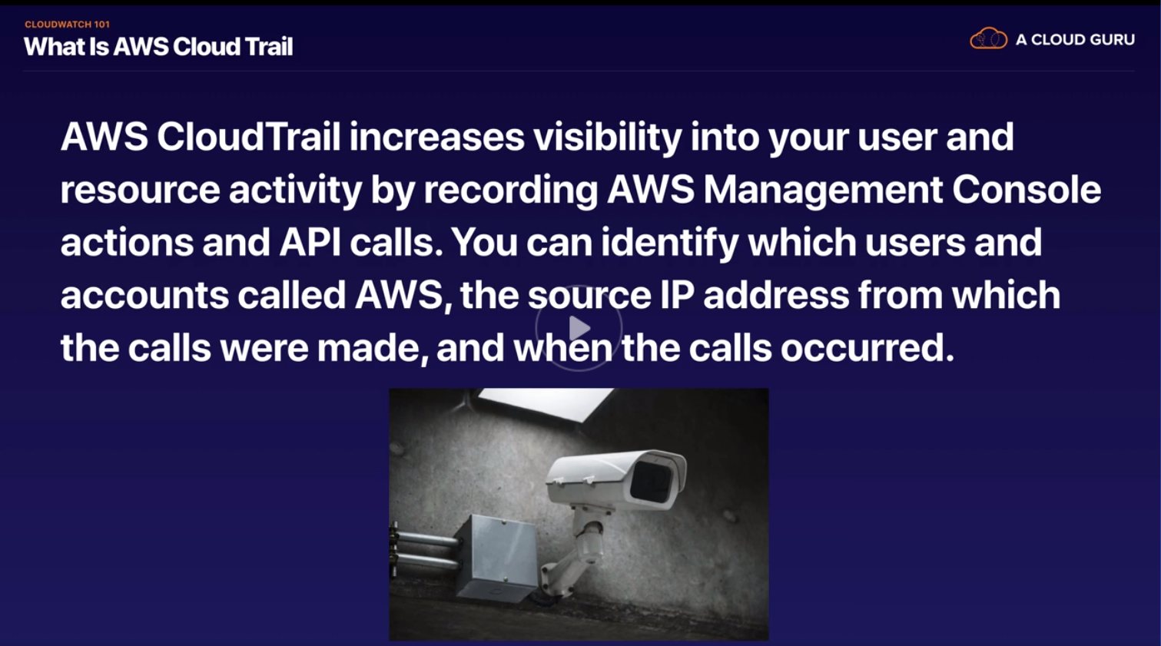

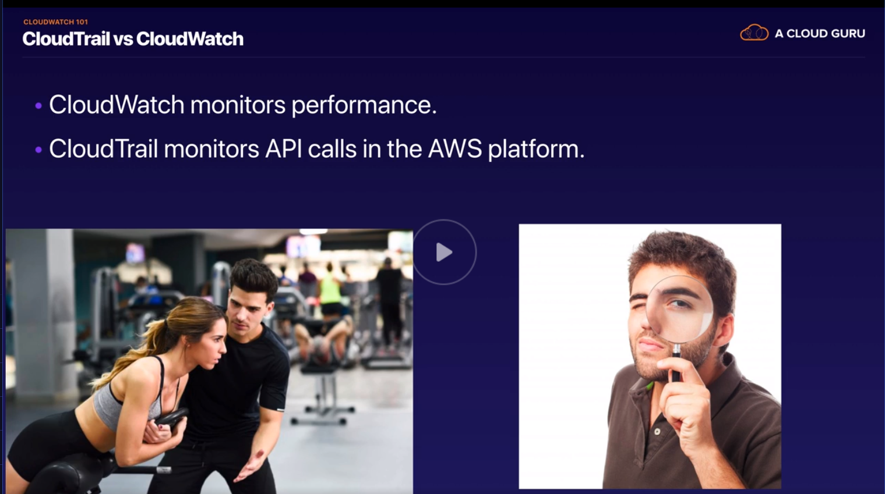

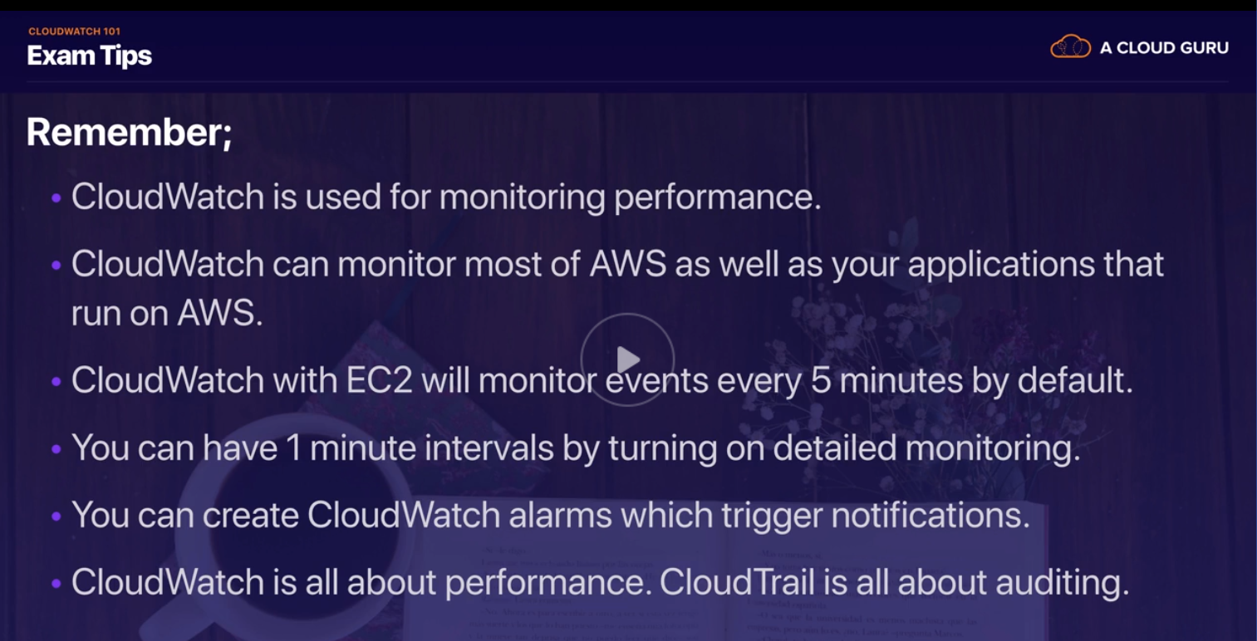



Got and create a new EC2 instance, at step 4 enable detailed monitoring which is at 1 minute interval and costs money , otherwise free one which is by default is every 5 mins

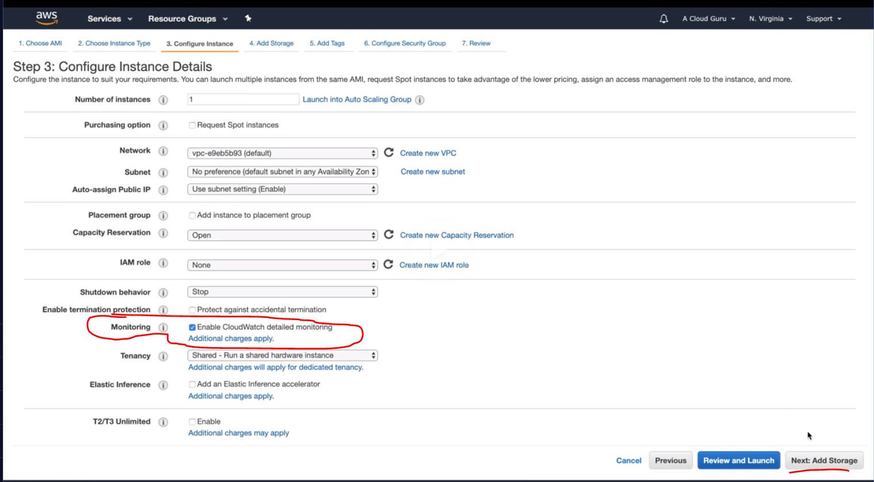

After launching observer below

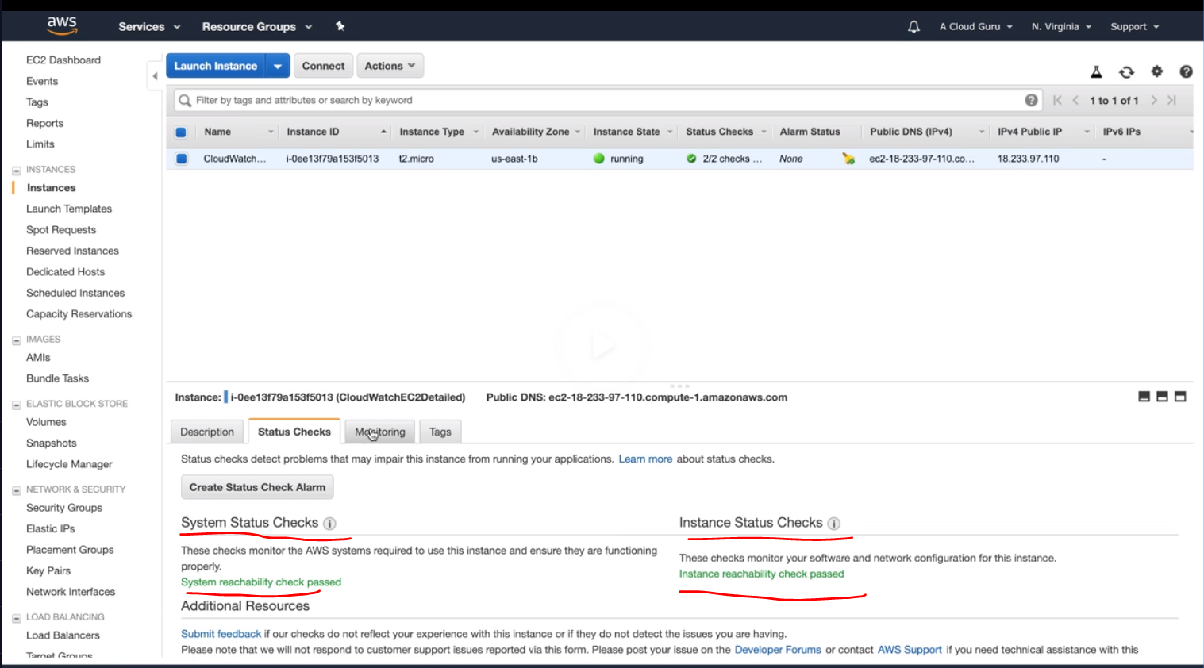

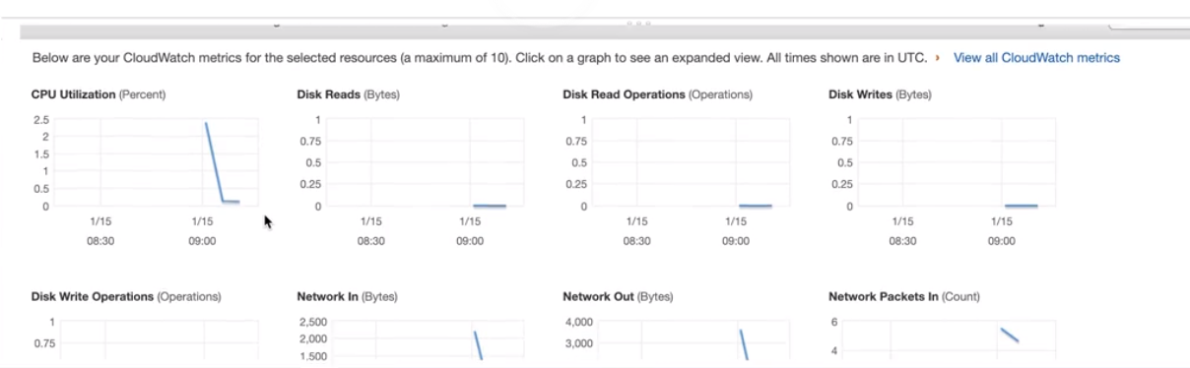

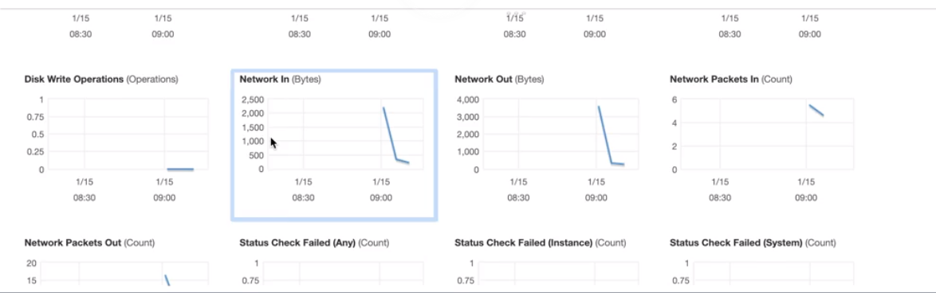

GAAAAAAAAAAAAAAAAAAAAAAAAAAAAP

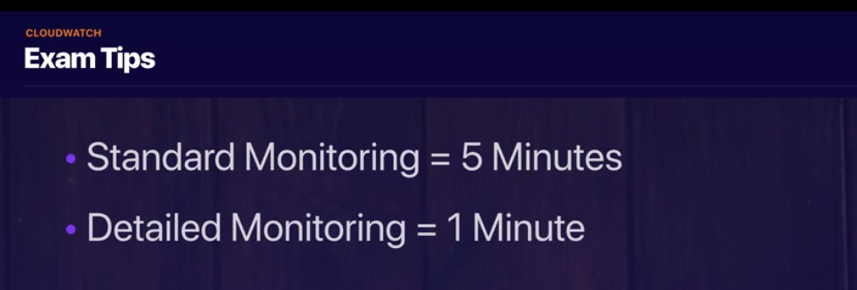

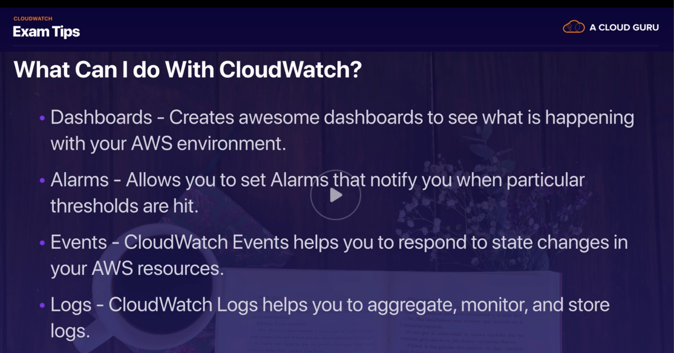

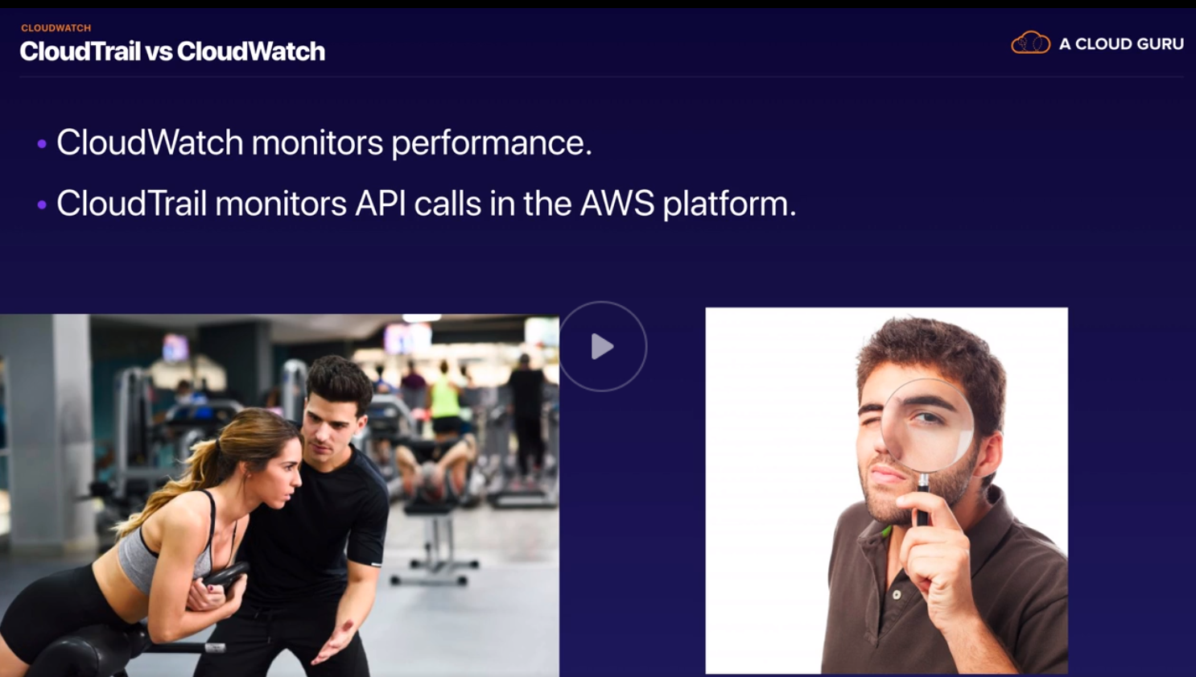

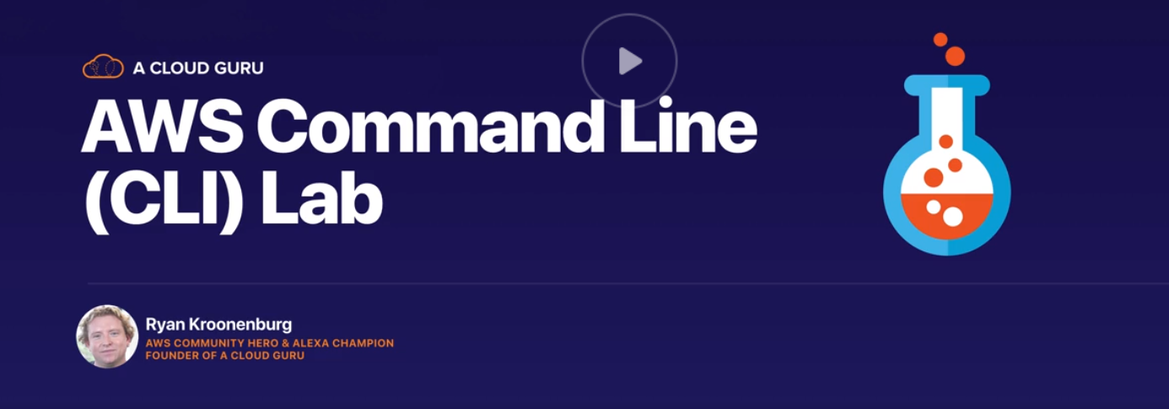

AWS CLI – Allows you to interact with AWS anywhere in the world

GAAAAAAAAAAAP

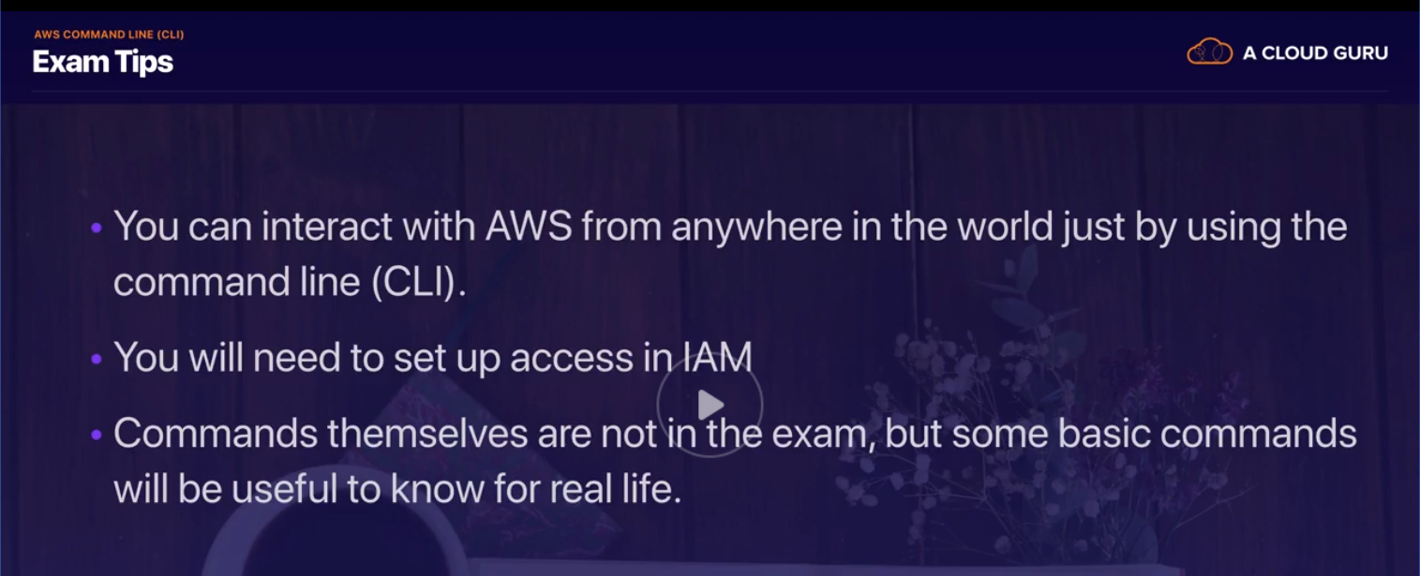

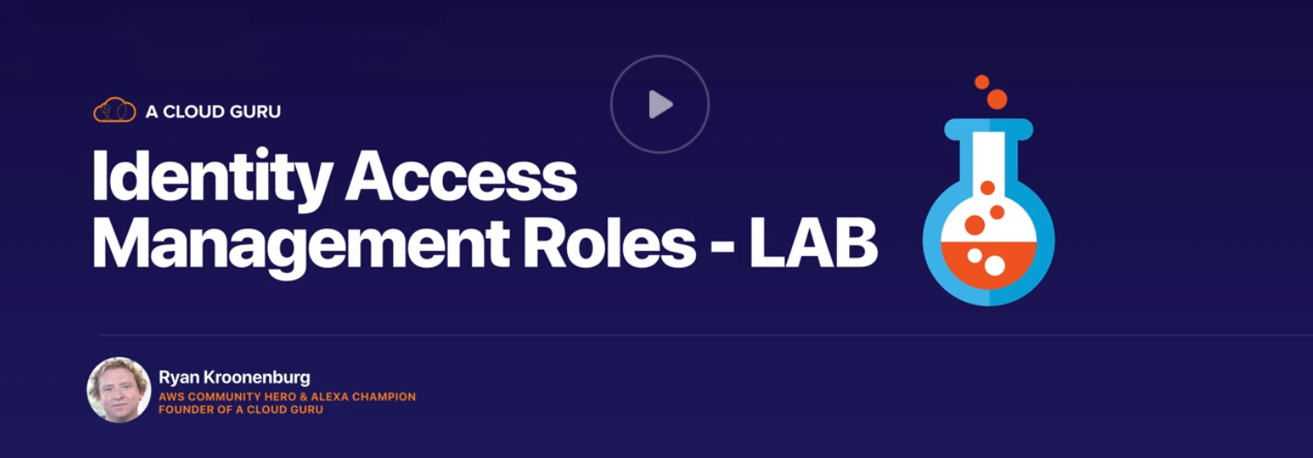

IN this section we create roles , so that we don’t have to pass access key and secret access key to every CLI user in the world

Go to services-IAM to create new roles

1. Create Role, attach a policy
2. Go to CLI and delete “.aws” directory so that access key and secret access keys are deleted
3. You will not be able to access EC2
4. Attach the role to EC2 instance
5. And now check

GAAAAAP

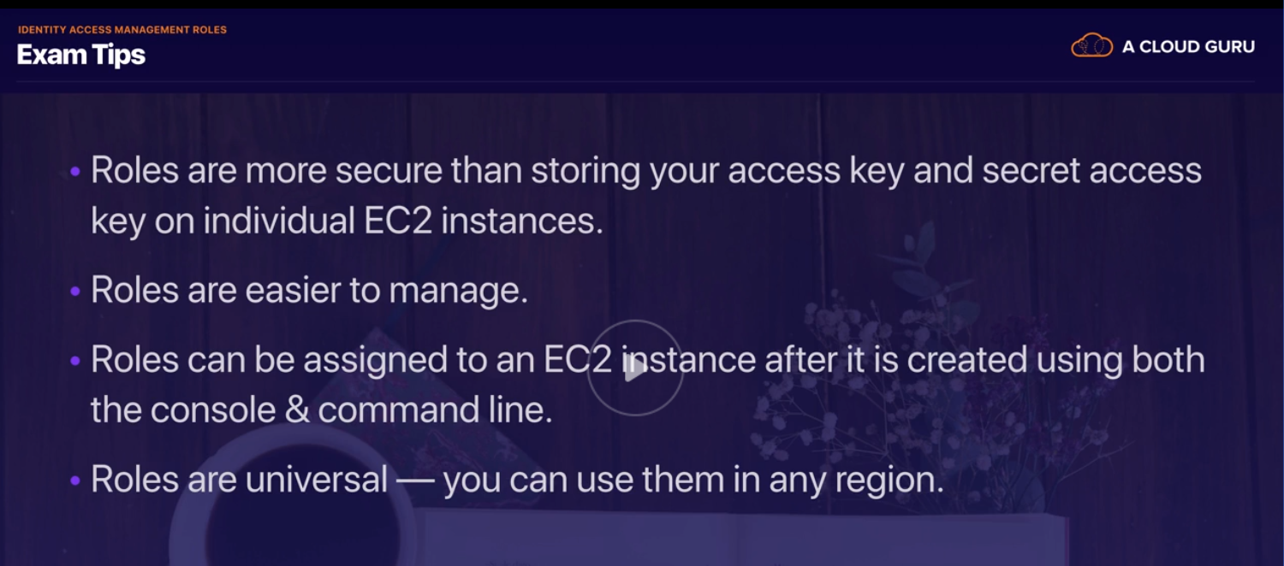



Boot Strap is automating AWS EC2 deployments

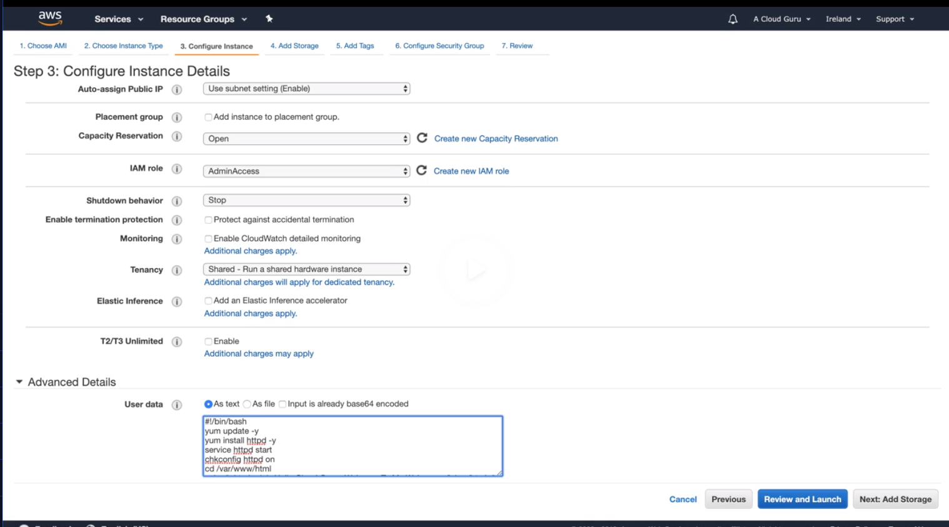

In step3 of launching the EC2, write a bash script to do below

1. Do update
2. Install Apache server
3. Start Apache service
4. Set config go start the service If there is a reboot
5. Go to html directory

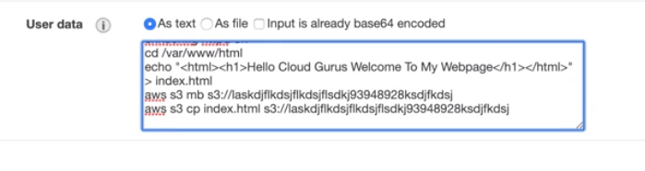

1. Create a little webpage
2. Create S3 bucket
3. Move the webpage to S3 bucket

Complete the launch of EC2, take the IPv4 address and hit it in browser

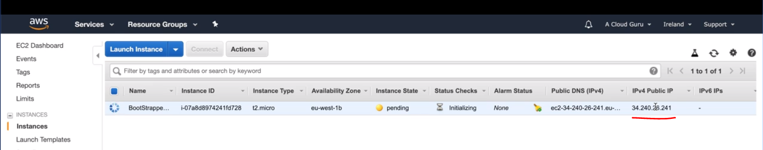

So the script is working

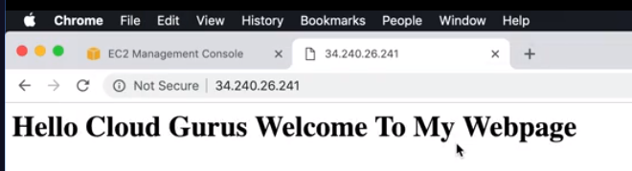

Now go to S3 bucket and see if the file has moved

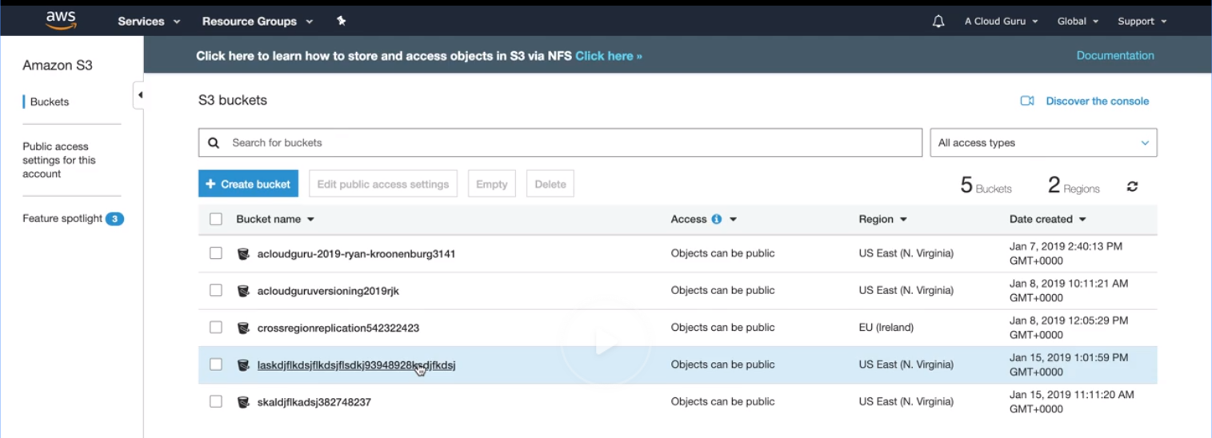

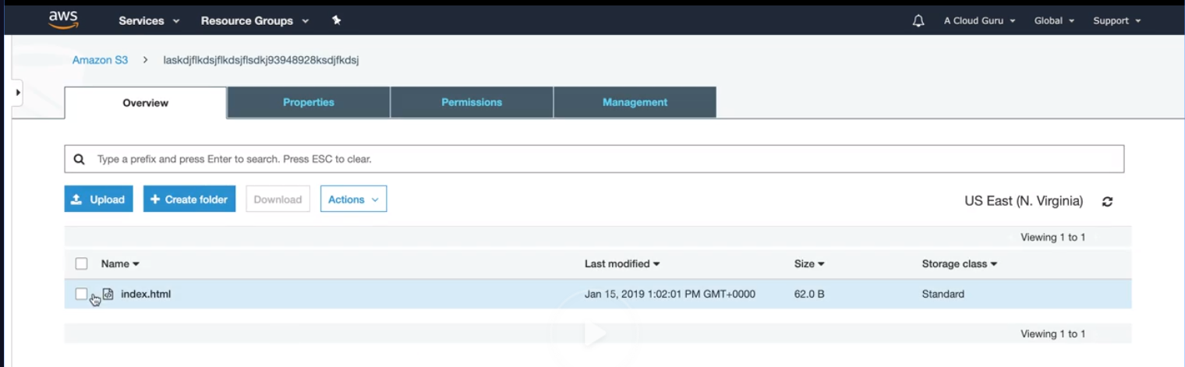



EC2 instance metadata and User data

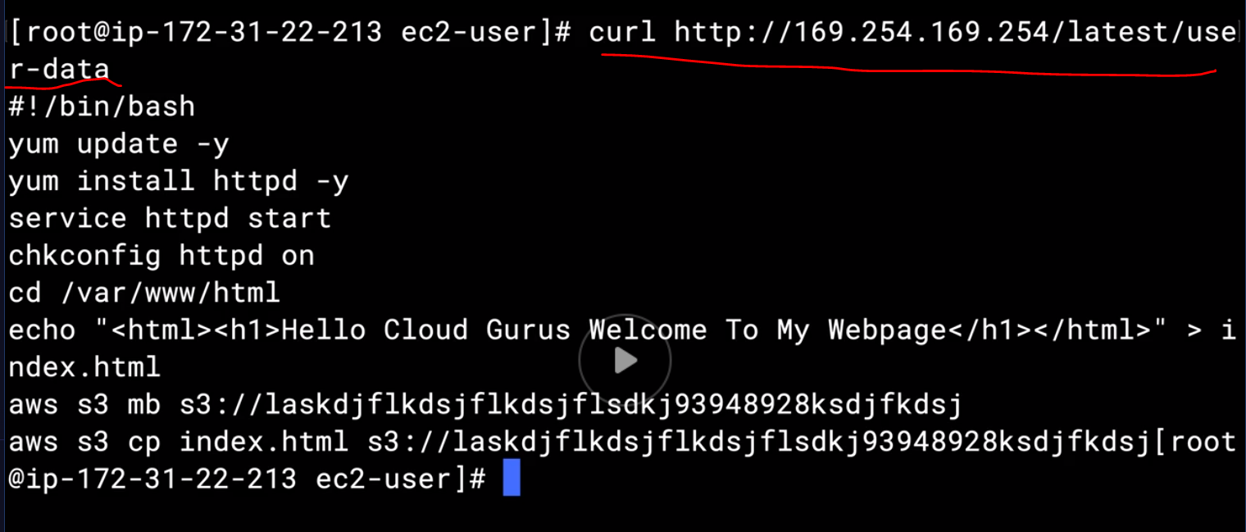

We can see boot strap script

Command to see metadata

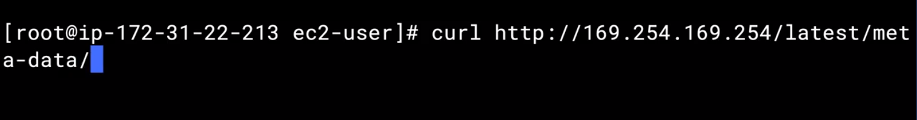

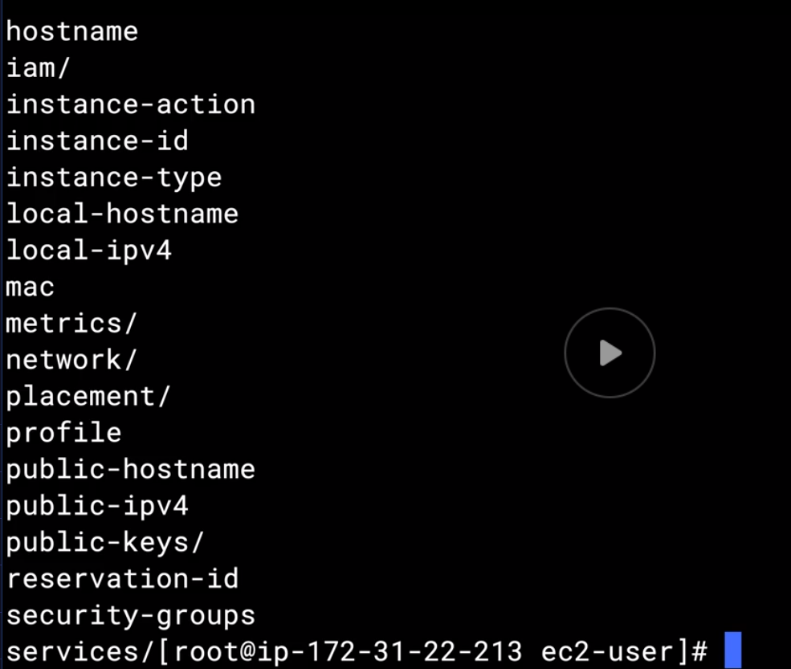

Command to see IP address

